1. my CNN model

epochs = 20

training time = 20 min

accuracy = 0.7833333333333333

# of parameters = 7153

Conv(filter_size=3, input_channel=1, output_channel=16)

* W + b = 3*3*1*16 + 1*1*1*16 = 160

Conv(filter_size=3, input_channel=16, output_channel=16)

* W + b = 3*3*16*16 + 1*1*1*16 = 2320

Dense(144, 32) => W + b = 32*144 + 32*1 = 4640

Dense(32, 1) => W + b = 1*32 + 1*1 = 33

160 + 2320 + 4640 + 33 = 7153

training loss curve =

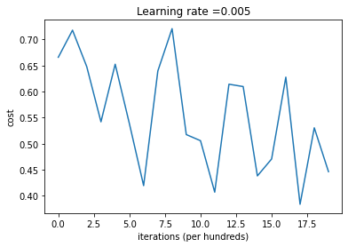

1. Tensorflow CNN model

epochs = 20

training time = 22 sec

accuracy = 0.8

# of parameters = 121474

training loss curve =

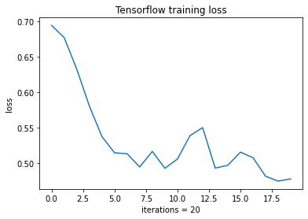

1. Advance part
2. Model structure

Data augmentation layer做了水平翻轉, rotation(factor=0.1)

1. Loss function

tf.keras.losses.SparseCategoricalCrossentropy(from_logits=True)

1. Optimizer: ADAM